Tracy Michaels

System Level Programming Lab 8

tmichaels1 002430918

Part 1

1-3)

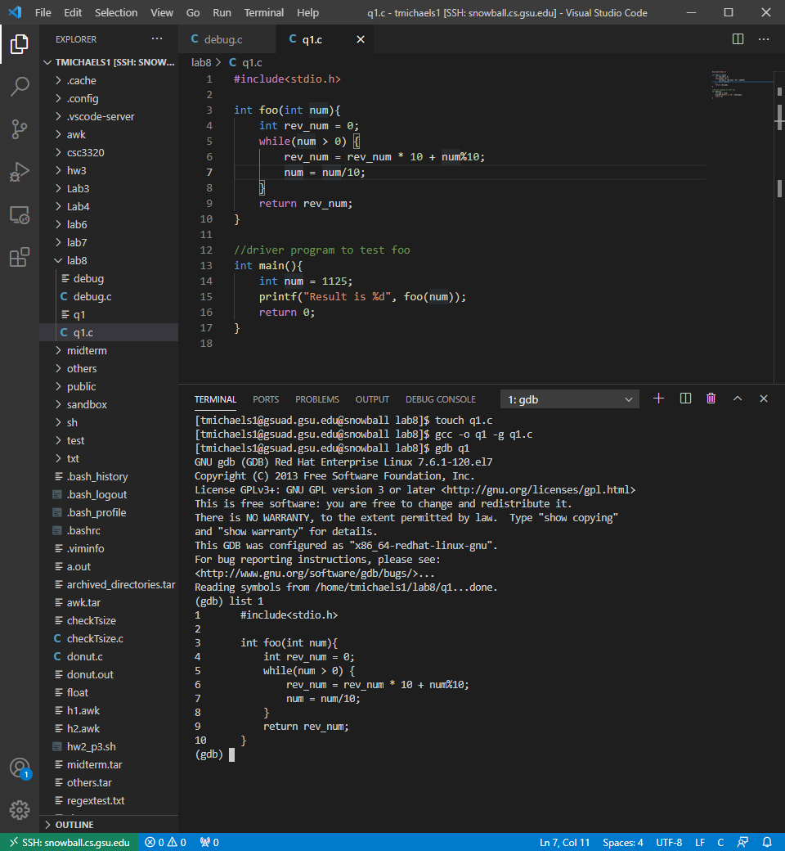

4) (gdb) break 5

4-2) (gdb) r

5)

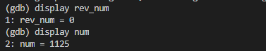

6)

|  |  |  |  |  |
| --- | --- | --- | --- | --- |
|  | 1st iteration | 2nd iteration | 3rd iteration | 4th iteration |
| num | 112 | 11 | 1 | 0 |
| rev_num | 5 | 52 | 521 | 5211 |

7) (gdb) quit

8) foo function reverses integers passed to it

Part 2

Line 11: wrap \n in single quotes

Line 13, 15, 19: variable space not declared. Added declaration and initialization to 0 at beginning of main and changed to isSpace for better clarification on what it is

Line 20: else statement missing closing bracket

Line 22: cast integers to floating point numbers as to not improperly truncate during division.

